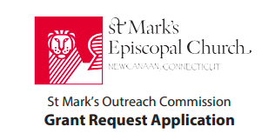

**Organization Name**:

**Principal contact for the Outreach Grant Commission’s communications: (Name, Telephone Number, E-mail address):**

**Amount of grant requested**:

Have you previously received grants from St. Mark’s? YES NO

What is the mission of your organization?

What are your organization’s current goals and priorities?

Is this grant request for a specific program or project or will it be directed to general operating support?

What achievements or successes over the last twelve months would you like to tell us about? What have been your greatest challenges?

Are you a subsidiary of another organization or affiliated with any other human service organization? If so, please identify. How long has your organization been in existence?

What are the principal funding sources for your organization?

How many people does your organization serve or impact annually?

How many, if any, are from New Canaan?

Do you utilize volunteers as well as paid staff? YES NO

Are members of St Mark’s Parish involved in your organization? YES NO

If yes, please provide the names of the key St. Mark's volunteers.

Do you need additional volunteer support? YES NO

Please provide:

1) your current year operating budget

2) last year’s financial statements

3) a copy of your Tax Determination Letter verifying your status as a 501(c)(3) organization.

Return completed application to the Rev. John Kennedy via email to: [jkennedy@stmarksnewcanaan.org](mailto:jkennedy@stmarksnewcanaan.org) or via postal mail to: St. Mark’s Epicopal Church, 111 Oenoke Ridge, New Canaan, CT 06840.